LAB 08
OPEN-ENDED-LAB

Open-Ended Lab Task: GitHub Integration and Concurrency in Java

Task Instructions:
- GitHub Repository Setup and Eclipse Integration
  - Create a new GitHub repository for this lab project.
  - Upload files from any eclipse workplace folder and commit changes to your GitHub repository.

Deliverable: Document the steps for creating the repository, setting up the Eclipse configuration

- Concurrency with Multithreading Mechanisms
  - Create a class with multiple threads that perform different tasks (e.g., one thread handles calculations, another handles data logging).
  - Implement the start, sleep, and stop functionalities to demonstrate different thread lifecycle states.
  - Use join() where necessary to ensure one thread completes before another begins, simulating dependency between threads.

CODE:

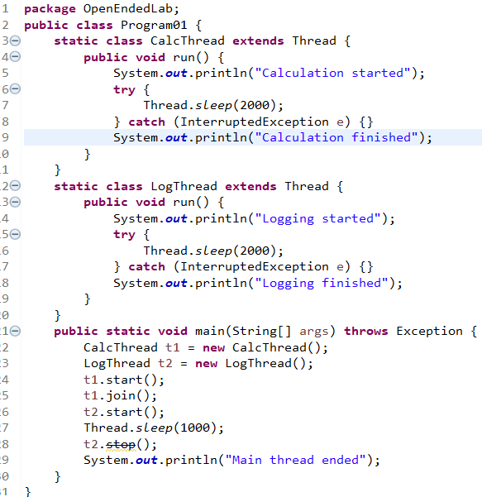
OUTPUT:

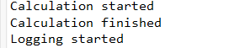

3. Inter-Thread Communication Using Synchronization
  - Develop a program where two threads communicate via shared resources.
  - Use synchronization techniques (such as synchronized methods or blocks) to ensure that shared resources are accessed safely by each thread.
CODE:

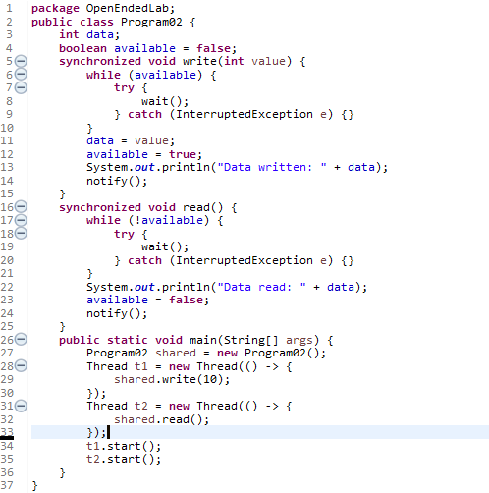

OUTPUT:

Additional Challenge:
- Experiment with ReentrantLock to replace synchronized blocks, allowing for finer control over thread locking.
- Add logging to record thread actions (such as start, wait, notify, stop) to a file for a clear view of thread operations over time.
CODE:

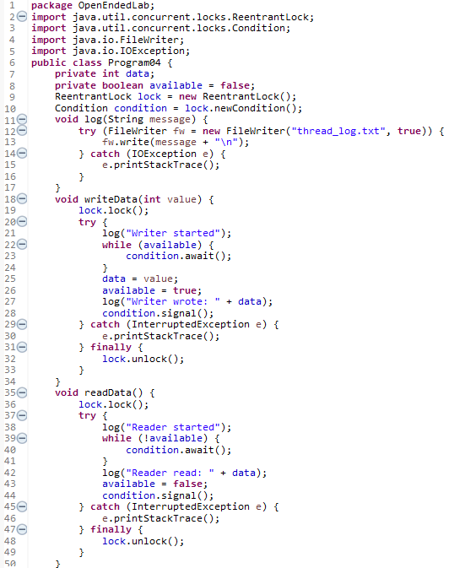

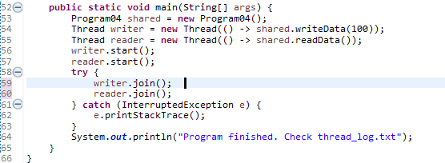

OUTPUT:

